Experiment No: 2

Title: Create a dynamic Billing Calculator using JavaScript objects, object destructuring, and DOM manipulation.

Software/Tools Required: Visual Studio Code (or any text editor), Web Browser (Google Chrome, Microsoft Edge, Firefox, etc.)

Theory: 1. JavaScript Objects: In JavaScript, an object is a standalone entity with properties and a type. It is a collection of key-value pairs used to store structured data. For example, a bill object can store a customer's name, product details, quantity, and total amount in a single grouped variable, making the data easier to manage.
2. Object Destructuring: Destructuring assignment is a modern JavaScript ES6 feature. It provides a syntax that makes it possible to unpack values from arrays, or properties from objects, into distinct and individual variables. This keeps the code clean and improves readability when extracting multiple properties from a complex object.
3. DOM Manipulation for Inputs and Outputs: Instead of using outdated and intrusive methods like prompt() for user input and document.write() for output, modern web development relies on the Document Object Model (DOM).
- Reading Inputs: Data is securely read from HTML form elements using methods like document.getElementById('id').value.
- Updating Output: The webpage is dynamically updated without reloading by injecting HTML structures into specific elements using the .innerHTML property.
4. Arithmetic Operators & Data Type Conversion JavaScript utilizes standard arithmetic operators (+, -, *, /) to compute business logic, such as multiplying quantity by price and calculating the 18% GST percentage. The Number() function is used to ensure string inputs from text boxes are properly converted into mathematical integers or floats before calculation.

Output:
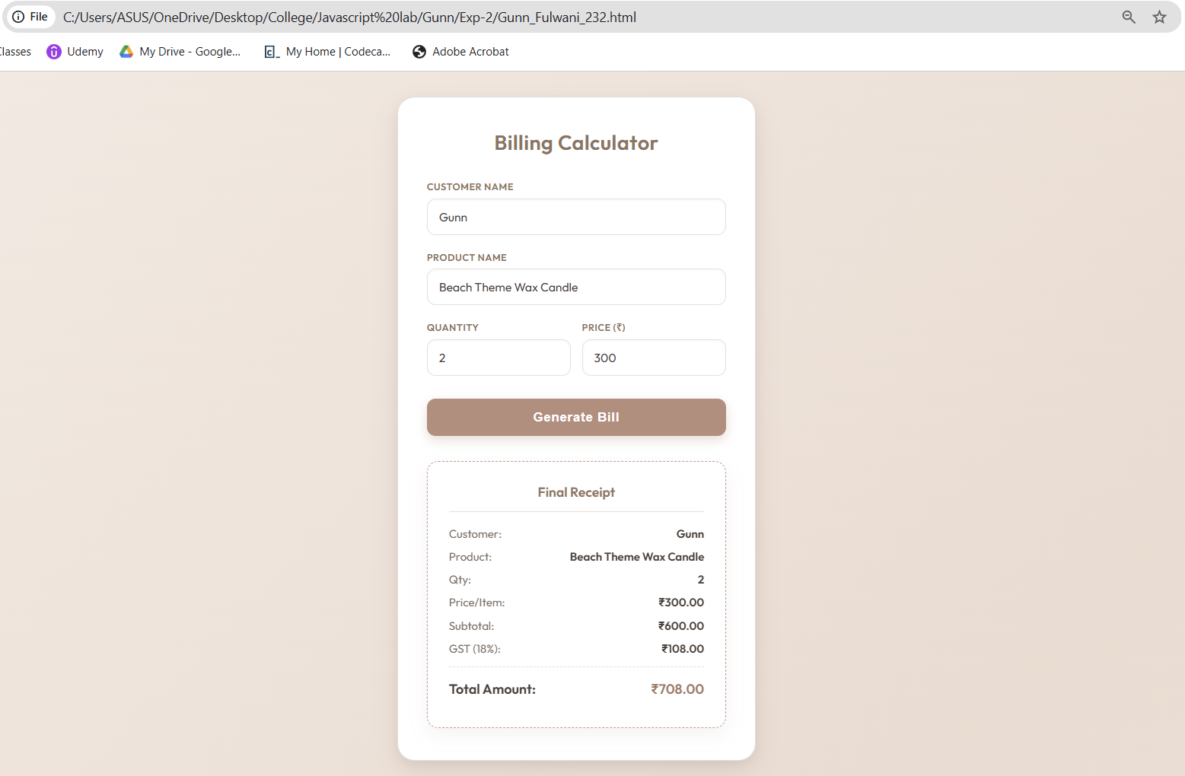

Result/Conclusion: The experiment was successfully completed. A dynamic and interactive billing calculator was developed using modern JavaScript principles. The use of outdated methods like prompt() and document.write() was effectively replaced with DOM manipulation, providing a clean and seamless user interface. Furthermore, the practical implementation of JavaScript objects and ES6 object destructuring provided a highly structured and efficient way to compute, store, and display invoice data.

